**Problems:**

I have taken YouTube Statistics dataset from Kaggle to perform MySQL activity, two CSV files are present inside the dataset one is video-stat other one is comment. In this activity I faced some problems which are described below with their solutions.

**Why Jupyter Notebook?**

For this purpose, I have used Jupyter Notebook with Python MySQL connector instead of MySQL workbench. Because of it’s good visibility like Question and their corresponding query is written in Markdown cell and code is written in code cell with output which is very understandable format.

**Why Pandas?**

**1. Unsupported Encoding Format:**

Very first problem that brought me toward Pandas is, I was unable to import the datasets into MySQL Workbench as tables inside a database because the dataset contains some type of special characters which are not supported in MySQL Workbench provided format like UTF-8, UTF-16 etc.

Whenever I was trying to import the table I was getting the following error, attached below.

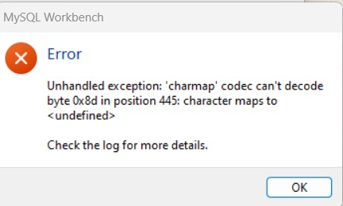

Forcefully, I tried to convert the whole dataset into UTF-8 but this did not work due to those special character present in the Video “Title” and “Comments” attributes.

So, I imported the dataset in Python as a Pandas DataFrame and with the help of SQLAlchemy converted the whole DataFrame into MySQL table or relation.

**2. Better Output Visualization:**

I have noticed, output of the queries provided by SQLAlchemy is understandable by Pandas so I converted the two-dimensional query output into Pandas DataFrame and showed them as Output.

**Why urllib?**

In order to connect our Jupyter Notebook to MySQL server, I had faced an issue that is my MySQL password contains a special character which was creating problem while I was creating the string for database connector. Because that binding string attributes (user name, password, hostname, port) are separated by special characters. So, I imported a module called urllib and used quote method inside parse module from urllib. In that process I was able to connect my Jupyter Notebook to MySQL server.